Post Lab 4

Checkpoint 1:

Q1,

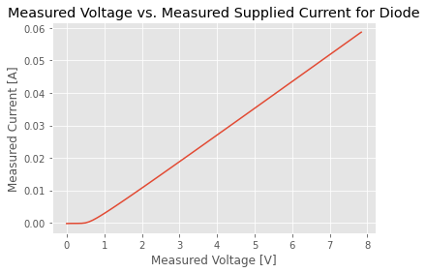

Q2,

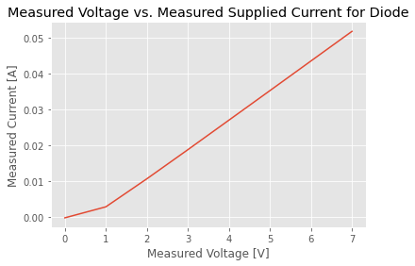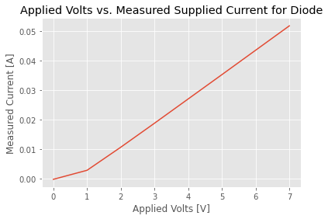

Comparing with 0.1 V step, 1 V step takes less sample so it has less detail on how current changes from 0 V to 1 V. Therefore, we cannot observe the diode voltage drop as clear as in 0.1V step, in which we can clearly see the current stay 0 until a certain voltage. However, for the rest of the result, they are basically the same since the I-V is linear.

Q3,

Depending on the precision needed for the measurement, for this particular exercise I think 1V to 0.5V step size would be sufficient, as it is vastly faster than smaller step sizes while showing the general trend of the I-V characteristic. The trade off would be lower step sizes takes longer to complete a given range but provide more resolution in the data set, and increasing step sizes would speed up the measurement sequence but loses resolution.

Python Code:

# NOTE 1

# If your power supply goes into an error state (i.e., the word

# error is printed on the front of the device), use this command

# power_supply.write("*CLS")

# to clear the error so that you can rerun your code. The supply

# typically beeps after an error has occured.

import pyvisa as visa # You should pip install pyvisa and restart the kernel.

import numpy as np

import matplotlib as mpl

import matplotlib.pyplot as plt

import time

mpl.style.use('ggplot')

#%%

# This section of the code cycles through all USB connected devices to the computer.

# The code figures out the USB port number for each instrument.

# The port number for each instrument is stored in a variable named “instrument_id”

# If the instrument is turned off or if you are trying to connect to the

# keyboard or mouse, you will get a message that you cannot connect on that port.

device_manager = visa.ResourceManager()

devices = device_manager.list_resources()

number_of_device = len(devices)

power_supply_id = -1;

waveform_generator_id = -1;

digital_multimeter_id = -1;

oscilloscope_id = -1;

# assumes only the DC power supply is connected

for i in range (0, number_of_device):

# check that it is actually the power supply

try:

device_temp = device_manager.open_resource(devices[i])

print("Instrument connect on USB port number [" + str(i) + "] is " + device_temp.query("*IDN?"))

if (device_temp.query("*IDN?") == 'HEWLETT-PACKARD,E3631A,0,3.2-6.0-2.0\r\n'):

power_supply_id = i

if (device_temp.query("*IDN?") == 'HEWLETT-PACKARD,E3631A,0,3.0-6.0-2.0\r\n'):

power_supply_id = i

if (device_temp.query("*IDN?") == 'Agilent Technologies,33511B,MY52301259,3.03-1.19-2.00-52-00\n'):

waveform_generator_id = i

if (device_temp.query("*IDN?") == 'Agilent Technologies,34461A,MY53207926,A.01.10-02.25-01.10-00.35-01-01\n'):

digital_multimeter_id = i

if (device_temp.query("*IDN?") == 'Keysight Technologies,34461A,MY53212931,A.02.08-02.37-02.08-00.49-01-01\n'):

digital_multimeter_id = i

if (device_temp.query("*IDN?") == 'KEYSIGHT TECHNOLOGIES,MSO-X 3024T,MY54440281,07.10.2017042905\n'):

oscilloscope_id = i

device_temp.close()

except:

print("Instrument on USB port number [" + str(i) + "] cannot be connected. The instrument might be powered of or you are trying to connect to a mouse or keyboard.\n")

#%%

# Open the USB communication port with the power supply.

# The power supply is connected on USB port number power_supply_id.

# If the power supply ss not connected or turned off, the program will exit.

# Otherwise, the power_supply variable is the handler to the power supply

if (power_supply_id == -1):

print("Power supply instrument is not powered on or connected to the PC.")

else:

print("Power supply is connected to the PC.")

power_supply = device_manager.open_resource(devices[power_supply_id])

#%%

# The power supply output voltage will be swept from 0 to 1.5V in steps of 0.05V.

# This voltage will be applied on the 6V output ports.

# For each voltage applied on the 6V power supply, we will measure the actual

# voltage and current supplied by the power supply.

# If your circuit operates correctly, the applied and measured voltage will be the same.

# If the power supply reaches its maximum allowed current,

# then the applied voltage will not be the same as the measured voltage.

output_voltage = np.arange(0, 8, 0.1)

measured_voltage = np.array([]) # create an empty list to hold our values

measured_current = np.array([]) # create an empty list to hold our values

print(power_supply.write("OUTPUT ON")) # power supply output is turned on

# loop through the different voltages we will apply to the power supply

# For each voltage applied on the power supply,

# measure the voltage and current supplied by the 6V power supply

for v in output_voltage:

# apply the desired voltage on teh 6V power supply and limist the output current to 0.5A

power_supply.write("APPLy P25V, %0.2f, 0.06" % v)

# pause 50ms to let things settle

time.sleep(0.5)

# read the output voltage on the 6V power supply

measured_voltage_tmp = power_supply.query("MEASure:VOLTage:DC? P25V")

measured_voltage = np.append(measured_voltage, measured_voltage_tmp)

# read the output current on the 6V power supply

measured_current_tmp = power_supply.query("MEASure:CURRent:DC? P25V")

measured_current = np.append(measured_current, measured_current_tmp)

# power supply output is turned off

print(power_supply.write("OUTPUT OFF"))

# close the power supply USB handler.

# Otherwise you cannot connect to it in the future

power_supply.close()

#%% Plot measured data. First convert the data from strings to numbers (ie floats)

voltage_list=np.zeros(np.size(output_voltage))

current_list=np.zeros(np.size(output_voltage))

for i in range(len(measured_voltage)):

voltage_list[i]= float(measured_voltage [i])

current_list[i]= float(measured_current[i])

# plot results (applied voltage vs measured supplied current)

plt.figure()

plt.plot(output_voltage, current_list)

plt.title("Applied Volts vs. Measured Supplied Current for Diode")

plt.xlabel("Applied Volts [V]")

plt.ylabel("Measured Current [A]")

plt.draw()

# plot results (measured voltage vs measured supplied current)

plt.figure()

plt.plot(voltage_list, current_list)

plt.title("Measured Voltage vs. Measured Supplied Current for Diode")

plt.xlabel("Measured Voltage [V]")

plt.ylabel("Measured Current [A]")

plt.draw()

# show all plots

plt.show()

Checkpoint 2

Q4,

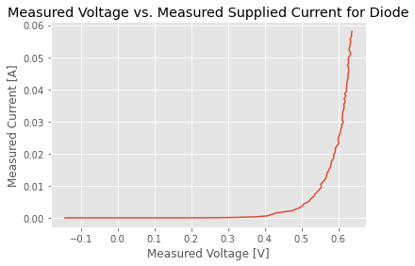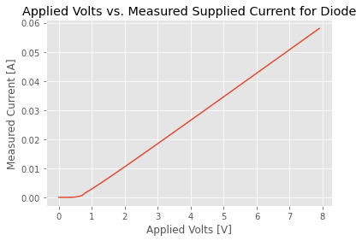

The new I-V shows a more obvious exponential trend, which is more inline with what we would expect. It is different from the first one because we are plotting the current of the whole circuit against voltage measured on the diode as opposed to the voltage supplied. Previously it is mostly linear because the exponential component is truncated by the linear component from the resistor (whose function is to prevent the circuit from blowing up).

Python:

# NOTE 1

# If your power supply goes into an error state (i.e., the word

# error is printed on the front of the device), use this command

# power_supply.write("*CLS")

# to clear the error so that you can rerun your code. The supply

# typically beeps after an error has occured.

import pyvisa as visa # You should pip install pyvisa and restart the kernel.

import numpy as np

import matplotlib as mpl

import matplotlib.pyplot as plt

import time

mpl.style.use('ggplot')

#%%

# This section of the code cycles through all USB connected devices to the computer.

# The code figures out the USB port number for each instrument.

# The port number for each instrument is stored in a variable named “instrument_id”

# If the instrument is turned off or if you are trying to connect to the

# keyboard or mouse, you will get a message that you cannot connect on that port.

device_manager = visa.ResourceManager()

devices = device_manager.list_resources()

number_of_device = len(devices)

power_supply_id = -1;

waveform_generator_id = -1;

digital_multimeter_id = -1;

oscilloscope_id = -1;

# assumes only the DC power supply is connected

for i in range (0, number_of_device):

# check that it is actually the power supply

try:

device_temp = device_manager.open_resource(devices[i])

print("Instrument connect on USB port number [" + str(i) + "] is " + device_temp.query("*IDN?"))

if (device_temp.query("*IDN?") == 'HEWLETT-PACKARD,E3631A,0,3.2-6.0-2.0\r\n'):

power_supply_id = i

if (device_temp.query("*IDN?") == 'HEWLETT-PACKARD,E3631A,0,3.0-6.0-2.0\r\n'):

power_supply_id = i

if (device_temp.query("*IDN?") == 'Agilent Technologies,33511B,MY52301259,3.03-1.19-2.00-52-00\n'):

waveform_generator_id = i

if (device_temp.query("*IDN?") == 'Agilent Technologies,34461A,MY53207926,A.01.10-02.25-01.10-00.35-01-01\n'):

digital_multimeter_id = i

if (device_temp.query("*IDN?") == 'Keysight Technologies,34461A,MY53212931,A.02.08-02.37-02.08-00.49-01-01\n'):

digital_multimeter_id = i

if (device_temp.query("*IDN?") == 'KEYSIGHT TECHNOLOGIES,MSO-X 3024T,MY54440281,07.50.2021102830\n'):

oscilloscope_id = i

device_temp.close()

except:

print("Instrument on USB port number [" + str(i) + "] cannot be connected. The instrument might be powered of or you are trying to connect to a mouse or keyboard.\n")

#%%

# Open the USB communication port with the power supply.

# The power supply is connected on USB port number power_supply_id.

# If the power supply ss not connected or turned off, the program will exit.

# Otherwise, the power_supply variable is the handler to the power supply

if (power_supply_id == -1):

print("Power supply instrument is not powered on or connected to the PC.")

else:

print("Power supply is connected to the PC.")

power_supply = device_manager.open_resource(devices[power_supply_id])

#%%

# Open the USB communication port with the power supply.

# The power supply is connected on USB port number power_supply_id.

# If the power supply ss not connected or turned off, the program will exit.

# Otherwise, the power_supply variable is the handler to the power supply

if (digital_multimeter_id == -1):

print("Digital multimeter instrument is not powered on or connected to the PC.")

else:

print("Digital multimeter is connected to the PC.")

digital_multimeter = device_manager.open_resource(devices[digital_multimeter_id])

#%%

# Open the USB communication port with the power supply.

# The power supply is connected on USB port number power_supply_id.

# If the power supply ss not connected or turned off, the program will exit.

# Otherwise, the power_supply variable is the handler to the power supply

if (oscilloscope_id == -1):

print("Oscilloscope instrument is not powered on or connected to the PC.")

else:

print("Oscilloscope is connected to the PC.")

oscilloscope = device_manager.open_resource(devices[oscilloscope_id])

#%%

# The power supply output voltage will be swept from 0 to 1.5V in steps of 0.05V.

# This voltage will be applied on the 6V output ports.

# For each voltage applied on the 6V power supply, we will measure the actual

# voltage and current supplied by the power supply.

# If your circuit operates correctly, the applied and measured voltage will be the same.

# If the power supply reaches its maximum allowed current,

# then the applied voltage will not be the same as the measured voltage.

output_voltage = np.arange(0, 8, 0.1)

measured_voltage = np.array([]) # create an empty list to hold our values

measured_current = np.array([]) # create an empty list to hold our values

print(power_supply.write("OUTPUT ON")) # power supply output is turned on

# loop through the different voltages we will apply to the power supply

# For each voltage applied on the power supply,

# measure the voltage and current supplied by the 6V power supply

for v in output_voltage:

# apply the desired voltage on teh 6V power supply and limist the output current to 0.5A

power_supply.write("APPLy P25V, %0.2f, 0.06" % v)

# pause 50ms to let things settle

time.sleep(0.5)

# read the output voltage on the 6V power supply

measured_voltage_tmp = oscilloscope.query("MEASure:VAVERAGE? DISPLAY, CHANNEL1")

measured_voltage = np.append(measured_voltage, measured_voltage_tmp)

# read the output current on the 6V power supply

measured_current_tmp = digital_multimeter.query("MEASure:CURRent:DC?")

measured_current = np.append(measured_current, measured_current_tmp)

# power supply output is turned off

print(power_supply.write("OUTPUT OFF"))

# close the power supply USB handler.

# Otherwise you cannot connect to it in the future

power_supply.close()

#%% Plot measured data. First convert the data from strings to numbers (ie floats)

voltage_list=np.zeros(np.size(output_voltage))

current_list=np.zeros(np.size(output_voltage))

for i in range(len(measured_voltage)):

voltage_list[i]= float(measured_voltage [i])

current_list[i]= float(measured_current[i])

# plot results (applied voltage vs measured supplied current)

plt.figure()

plt.plot(output_voltage, current_list)

plt.title("Applied Volts vs. Measured Supplied Current for Diode")

plt.xlabel("Applied Volts [V]")

plt.ylabel("Measured Current [A]")

plt.draw()

# plot results (measured voltage vs measured supplied current)

plt.figure()

plt.plot(voltage_list, current_list)

plt.title("Measured Voltage vs. Measured Supplied Current for Diode")

plt.xlabel("Measured Voltage [V]")

plt.ylabel("Measured Current [A]")

plt.draw()

# show all plots

plt.show()